October 5, 2020 Furuoya

Tra loi cau hoi cua Troi san

1．DEPARTMENT

［Question］Why we need add this column to “job Time” table?

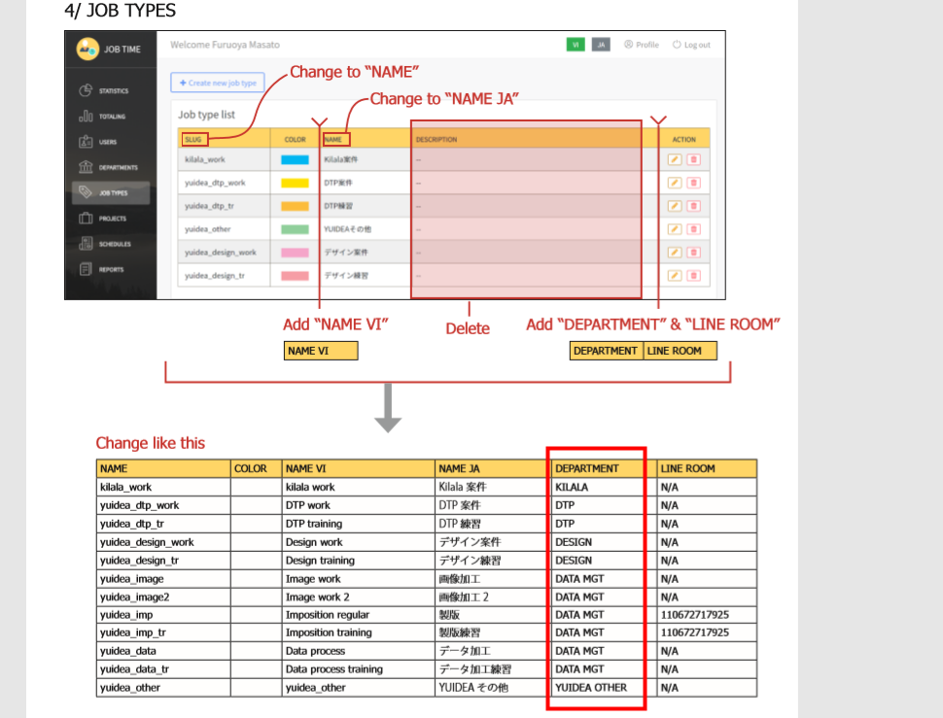

［Reply］「DEPARTMENT」 la bo phan cua YUIDEA. Cong viec cua cac bo phan se khac nhau. Vi can phai thong ke viec cua cac bo phan nen la tach rieng ra nhu vay la can thiet

2．Multiple Teams[1]

［Question］A project has multiple teams. Is that right?

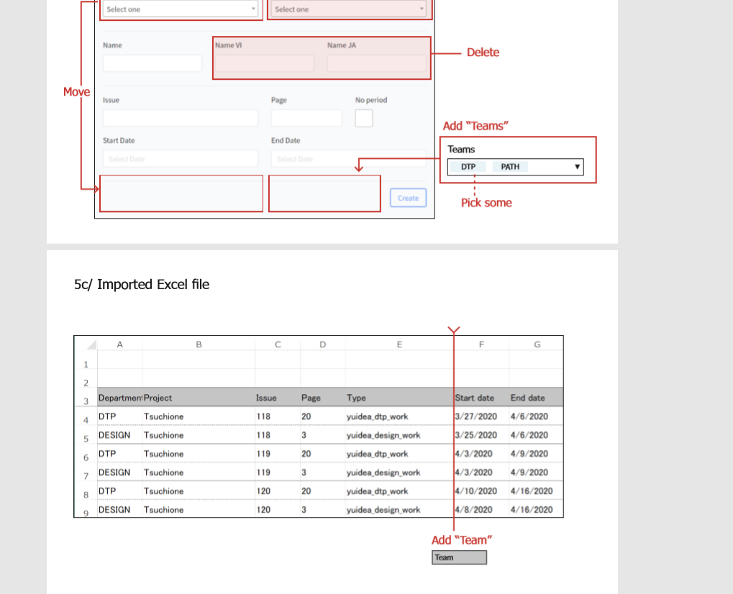

[Reply]

YES

Tuy the project ma co truong hop co lien quan den ca DTP va Path. Vi vay khi lam project thi phai set multiple teams.

3．Multiple Teams[2]

［Question］A schedule also has multiple teams. Is that right?

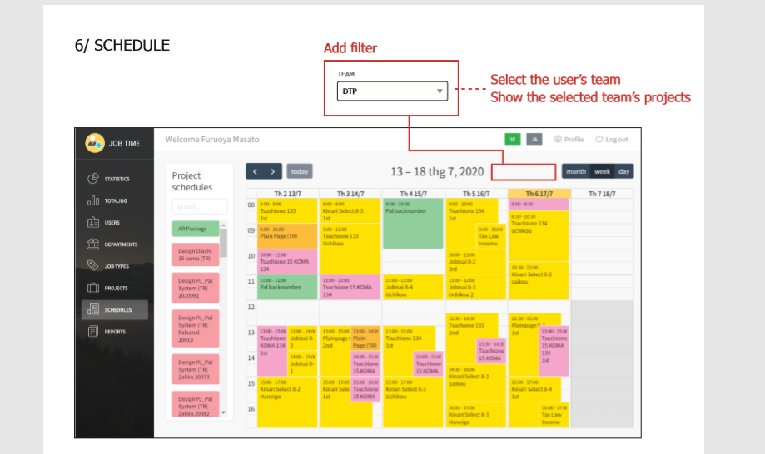

[Reply]YES

Co truong hop thanh vien DTP thuc hien cong viec team Path va nguoc lai. Noi cach khac la viec co the nhin thay dc schedule cua ca 2 la can thiet.

以上